School of Informatics & Cybersecurity - Assessment Submission Coversheet

Student Information
Student Number: | B00162371
Student Name: | Isabella Higgins

Module Information
Module Title: | Rich Web Apps
Module Code: | COMP H3026

Assessment Information
Assessment Title: | Assignment 1

Declaration
I confirm that I have read and understood the University’s Plagiarism Policy.
I declare that this assessment submission is my own work.
I confirm that I have not used generative AI tools (e.g., ChatGPT, DALL·E, etc.) to assist in completing this assessment.
Student Signature: Isabella Higgins
Date: 07/12/25

Github link:
https://github.com/isabellahiggins/project_RWA

Wireframes:
/login
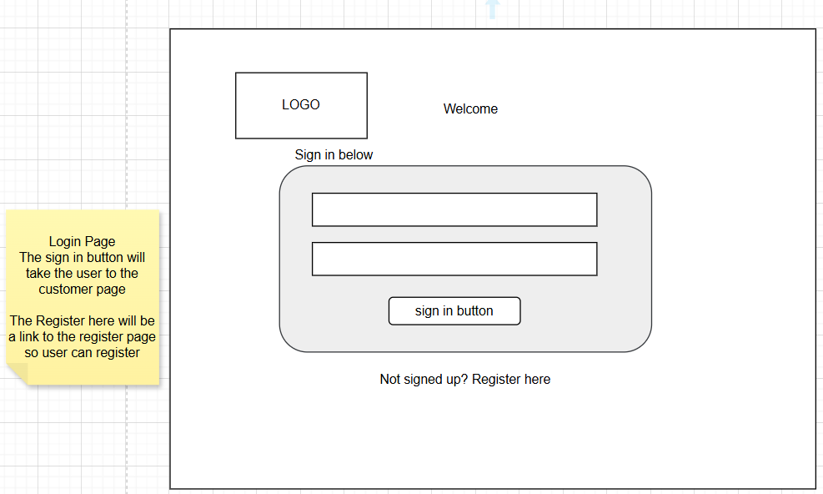

/register
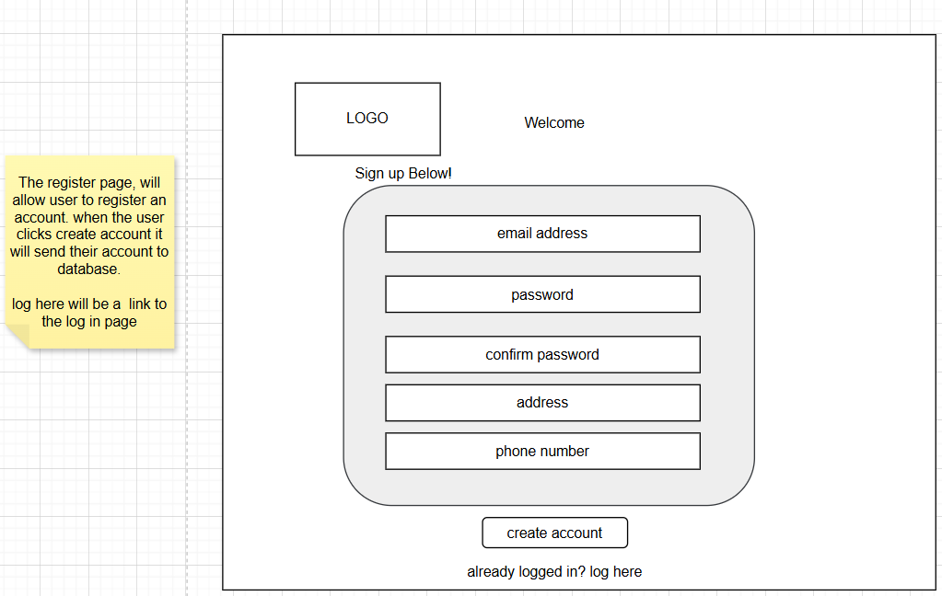
/customer
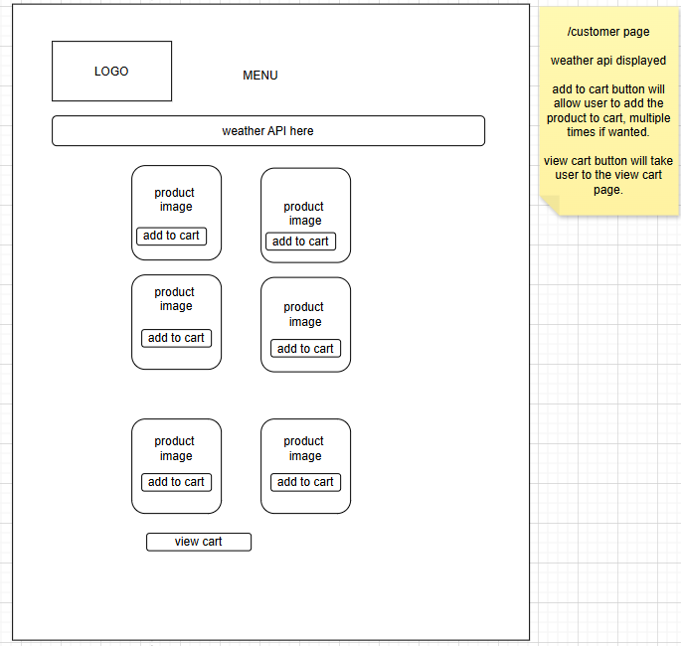
/checkout
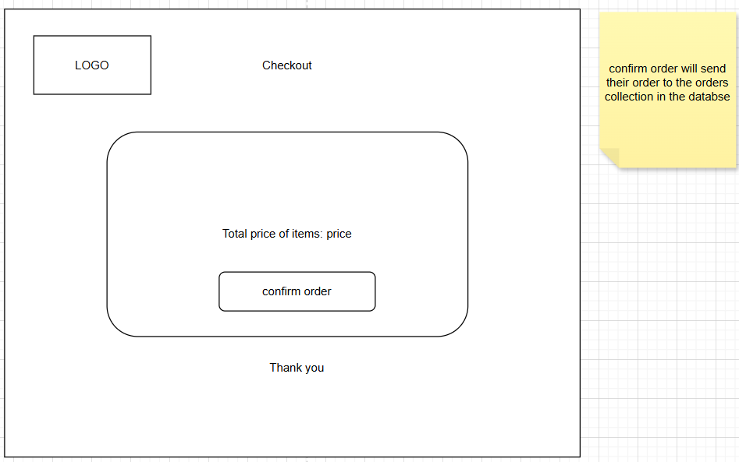

/viewcart
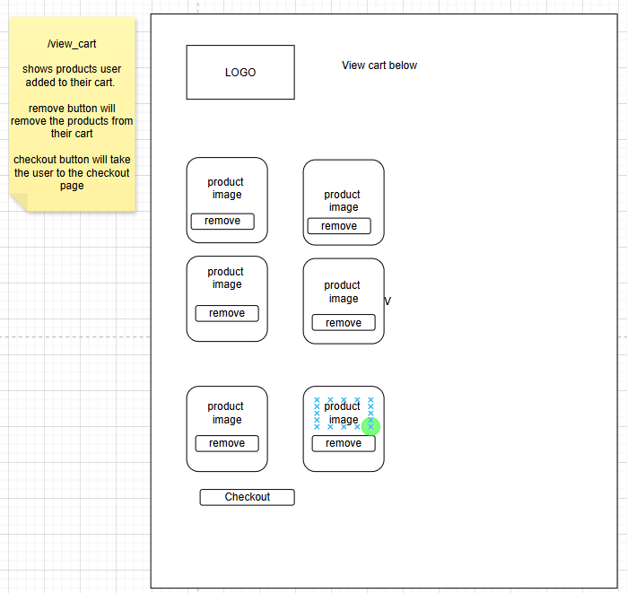

Database
